Cyberspace When You’re Dead


‘‘Sunset Portraits, From 8,462,359 Sunset Pictures on Flickr, 12/21/10’’Credit...Photo Illustration by Penelope Umbrico for The New York Times
By Rob Walker Jan. 5, 2011
Suppose that just after you finish reading this article, you keel over, dead. Perhaps you’re ready for such an eventuality, in that you have prepared a will or made some sort of arrangement for the fate of the worldly goods you leave behind: financial assets, personal effects, belongings likely to have sentimental value to others and artifacts of your life like photographs, journals, letters. Even if you haven’t made such arrangements, all of this will get sorted one way or another, maybe in line with what you would have wanted, and maybe not.
But many of us, in these worst of circumstances, would also leave behind things that exist outside of those familiar categories. Suppose you blogged or tweeted about this article, or dashed off a Facebook status update, or uploaded a few snapshots from your iPhone to Flickr, and then logged off this mortal coil. It’s now taken for granted that the things we do online are reflections of who we are or announcements of who we wish to be. So what happens to this version of you that you’ve built with bits? Who will have access to which parts of it, and for how long?
Not many people have given serious thought to these questions. Maybe that’s partly because what we do online still feels somehow novel and ephemeral, although it really shouldn’t anymore. Or maybe it’s because pondering mortality is simply a downer. (Only about a third of Americans even have a will.) By and large, the major companies that enable our Web-articulated selves have vague policies about the fate of our digital afterlives, or no policies at all. Estate law has only begun to consider the topic. Leading thinkers on technology and culture are understandably far more focused on exciting potential futures, not on the most grim of inevitabilities.
Nevertheless: people die. For most of us, the fate of tweets and status updates and the like may seem trivial (who cares — I’ll be dead!). But increasingly we’re not leaving a record of life by culling and stowing away physical journals or shoeboxes of letters and photographs for heirs or the future. Instead, we are, collectively, busy producing fresh masses of life-affirming digital stuff: five billion images and counting on Flickr; hundreds of thousands of YouTube videos uploaded every day; oceans of content from 20 million bloggers and 500 million Facebook members; two billion tweets a month. Sites and services warehouse our musical and visual creations, personal data, shared opinions and taste declarations in the form of reviews and lists and ratings, even virtual scrapbook pages. Avatars left behind in World of Warcraft or Second Life can have financial or intellectual-property holdings in those alternate realities. We pile up digital possessions and expressions, and we tend to leave them piled up, like virtual hoarders.
At some point, these hoards will intersect with the banal inevitability of human mortality. One estimate pegs the number of U.S. Facebook users who die annually at something like 375,000 [2021 - now 3m]. Academics have begun to explore the subject (how does this change the way we remember and grieve?), social-media consultants have begun to talk about it (what are the legal implications?) and entrepreneurs are trying to build whole new opportunity here?). Evan Carroll and John Romano, interaction-design experts in Raleigh, N.C., who run a site called TheDigitalBeyond.com, have just published a tips-and-planning book, “Your Digital Afterlife,” with advice about such matters as appointing a “digital executor.”
Adele McAlear, a social-media and marketing consultant, became interested in this subject a few years ago, when one of her regular Twitter contacts died. A Web enthusiast who has created “Lord knows how many profiles” for herself in the course of road-testing various new services, she is an “advocate of creating content and putting it online.” And yet, she continues, it “hadn’t dawned on me, what happens to all of this stuff that you put out there, this digital litter that sort of accumulates.” That may be particularly true for people like McAlear, who have thoroughly integrated their Web expressions into their identity. (Indeed, she explores her new interest on a blog, DeathandDigitalLegacy.com.) But you don’t have to be a social-media consultant to live that way. More and more people do, as a matter of course. Millions of us are “sharing” our thoughts and tastes; our opinions and observations about WikiLeaks and “Glee” and the Tea Party and some weird dude on the subway this morning; and photographs of newborns and weddings and parties and — why not? — that weird dude on the subway. Maybe the momentous and the momentarily amusing add up to a pleasing means of real-time connection, but what do they add up to when we’re gone? The legacy of a life you hope your survivors will remember? Or a jumble of “digital litter” for them to sort through?
ON OCT. 18, 2009, Mac Tonnies updated his blog, sent out some public tweets and private messages via Twitter, went to bed and died of cardiac arrhythmia. While he had experienced some symptoms that indicated potential heart problems, his sudden death came as a shock even to those who knew him well. He was 34.
Tonnies lived in Kansas City, Mo. He was single and childless, owned two cats and paid his bills through workaday jobs, behind the counter at Starbucks or doing phone work for a small marketing agency. He was also a writer (he had just finished a draft of his third book) with an adventurous intellect. His audience was small, but devoted. Tonnies, who started his blog, Posthuman Blues, in 2003, was an extremely active user of online media and forged many friendships with people he never met in the physical world. Many of his interests were distinctly future-oriented, including speculative or fringe topics that sound to most people like science fiction. Often this was the common ground of those online relationships: a freewheeling consideration of the very nature of humanity.
Rita J. King, an expert on online identity and persona who is an “innovator in residence” for I.B.M., was introduced to Tonnies via e-mail in 2004, and they kept in frequent touch. “He is the one I had all my conversations with, early on, about technology and consciousness,” she says. Possibly a typical venti latte buyer in Kansas City would have found that puzzling and dismissed some of Tonnies’s other interests (U.F.O.’s, life on Mars, the paranormal) as flat-out weird. But online, he wasn’t some guy with a lot of strange ideas. He was himself. And he attracted an eclectic group of similarly minded friends.

Editors’ Pic

The last entry on Posthuman Blues was titled “Tritptych #15,” a set of three images with no text. The first comment to this post came from an anonymous reader, wondering why Tonnies had not updated the blog or tweeted for two days. Some similar comments followed, and then this: “Mac Tonnies passed away earlier in the week. Our condolences are with his family and friends in this time of grief.” The author of that comment was also anonymous. After a rapid back-and-forth about whether this startling news was true and some details of the circumstances, that post’s comment section transformed into a remarkable mix of tributes, grieving and commiseration. You can still read all this today, in a thread that runs to more than 250 comments.
“It was a very strange feeling,” Dana Tonnies, Mac’s mother, told me, describing how she and her husband became aware of the swirl of activity attaching to her son’s online self. “I had no control over what was being said about him, almost immediately.” Dana and Bob Tonnies were close to their only son — in fact they had coffee with him, in a regular Sunday ritual, the morning before he died — but they had little contact with his digital self. Sometimes he would show them his online writing, but he had to do so by literally putting his laptop in front of them. The Tonnies did not read blogs. In fact they did not own a computer.
In the months after their son’s death, Dana and Bob went about the difficult business of organizing his papers (letters, e-mail printouts, story drafts) and deciding which of his belongings to keep (like his thousand or so books) or to give to his friends (his leather jacket, his three watches). This painful process took awhile, and they were not really focused on his blog or Flickr account and the like. They also inherited their son’s computer and have since learned how to navigate it and the Internet. But by then, their son’s online circle had already taken action.
I spoke to a half dozen people Mac Tonnies met online and in some cases never encountered in the physical world. Each expressed a genuine sense of loss; a few sounded grief-stricken even more than a year later. Mark Plattner, who lives in St. Louis and met Tonnies a dozen years ago through the comments section of another blog, decided that Posthuman Blues needed to survive. He used software called Sitesucker to put a backup of the entire thing — pictures, videos, links included — on a hard drive. In all, Plattner has about 10 gigabytes of material, offering a sense of Tonnies’s “personality and who he was,” Plattner says. “That’s what we want to remember.” He intends to store this material through his own hosting account, just as soon as he finds time to organize it all.
Plattner was one of several online friends who got involved in memorializing Tonnies and his work. Dia Sobin, an artist who lives in Connecticut, met Tonnies online around 2006; they communicated often by e-mail and phone, but never met in person. She created art for Tonnies’s site and for the cover of what turned out to be his final book. Less than two weeks after he died, she started a blog called Post-Mac Blues. For more than a year, she filled it with posts highlighting passages of his writing, reminiscences, links to interviews he gave to podcasters and bloggers, even his Blip.fm profile (which dutifully records that he listened to a song from “Everything That Happens Will Happen Today,” by David Byrne and Brian Eno, at 4:16 p.m. on the last day he lived). Her site is “a map to Mac Tonnies,” Sobin says. “And a memorial.”
“I only ever knew him over Twitter,” Sarah Cashmore , a graduate student in Toronto, told me. She shared his enthusiasm for design and technology and learned of his death from Twitter contacts. “I was actually devastated,” she says. A few months later, she teamed up with several other members of Tonnies’s Twitter circle to start a second Tonnies-focused blog, Mac-Bots.

This outpouring of digital grief, memorial-making, documentation and self-expression is unusual, maybe unique, for now, because of the kind of person Tonnies was and the kinds of friends he made online. But maybe, his friend Rita King suggests, his story is also a kind of early signal of one way that digital afterlives might play out. And she doesn’t just mean this in an abstract, scholarly way. “I find solace,” she told me, “in going to Mac’s Twitter feed.”
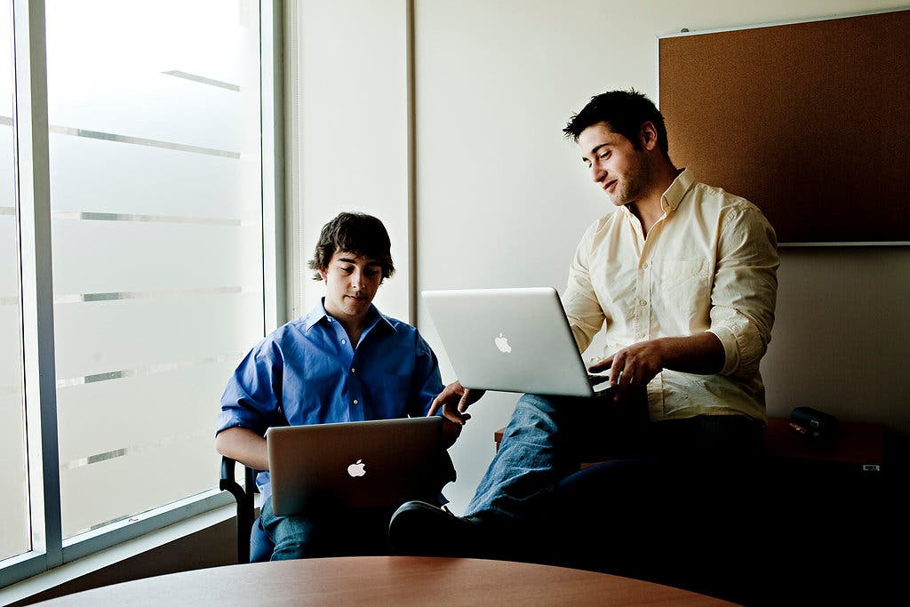
DIGITAL CARETAKERS The founders of Entrustet, Nathan Lustig, left, and Jesse Davis.Credit...Tomas Munita for The New York Times
Finding solace in a Twitter feed may sound odd, but the idea that Tonnies’s friends would revisit and preserve such digital artifacts isn’t so different from keeping postcards or other physical ephemera of a deceased friend or loved one. In both instances, the value doesn’t come from the material itself but rather from those who extract meaning from, and give meaning to, all we leave behind: our survivors.
The most remarkable set of connections to emerge from Tonnies’s digital afterlife isn’t among his online friends — it is between those friends and his parents, the previously computer-shunning Dana and Bob Tonnies. Dana, who told me that her husband now teases her about how much time she spends sending and answering e-mail (a good bit of it coming from her son’s online social circle), is presently going through Posthuman Blues, in order, from the beginning. “I still have a year to go,” she says. Reading it has been “amazing,” she continues — funny posts, personal posts, poetic posts, angry posts about the state of the world. I ask her if what she is reading seems like a different, or specifically narrow, version of her son. “Oh, no, it’s him,” she says. “I can hear him when I read it.”
Mac Tonnies’s digital afterlife stands as a kind of best-case scenario for preserving something of an online life, but even his case hasn’t worked out perfectly. His “Pro” account on the photo-sharing service Flickr allowed him to upload many — possibly thousands — of images. But since that account has lapsed, the vast majority can no longer be viewed. Some were likely gathered in Plattner’s backup of Tonnies’s blog; others may exist somewhere on his laptop, though Dana Tonnies still isn’t sure where to look for them. All could be restored if Tonnies’s “Pro” account were renewed. But there’s no way to do that — or to delete the account, for that matter: no one has the password Tonnies used with Flickr, which is owned by Yahoo. He used Blogspot for Posthuman Blues; that’s a free Google product, and there are no fees to keep it updated or any immediate danger of it disappearing. On the other hand, there’s no guarantee of how long it will remain. Updating, altering or maintaining it would require Tonnies’s password, which he didn’t leave behind. Obtaining that password from Google would require providing the company with proof of death. As lovely and moving as the tributes and communal mourning that appeared in the comments to his final post are, it’s jarring to see the thread gradually infiltrated by spam-bots — pidgin-English comments followed by long lists for links for “cheap Ugg boots” and such. It’s like finding a flier for a dry cleaner stuck among flowers on a grave, except that it’s much harder to remove.
It’s unlikely the material Tonnies left online would have fared as well had it not been for his savvy and generous circle of Web friends. For most survivors, coping with the physical possessions and conventional assets of the departed can be overwhelming enough, but at least there are parameters and precedents. Even if a houseful of objects is liquidated through an estate sale or simply junked, mechanisms exist to ensure some sort of definitive outcome, even in the absence of a will. And there’s no way of ignoring or forgetting it: eventually the stuff will have to be dealt with.
Bit-based personal effects are different. Survivors may not be aware of the deceased’s full digital hoard, or they may not have the passwords to access the caches they do know about. They may be uncertain to the point of inaction about how to approach the problem at all. Any given e-mail account, for instance, can include communication as trivial as an “I’m running late” phone call or as thoughtful as a written letter — all jumbled together, by the hundreds or thousands. Similarly, let’s just say not all of us are discriminating curators in uploading pictures to Facebook, for instance, flinging more images from one weekend onto the Web than an earlier generation would have saved from a weeks-long vacation. When you inherit a physical scrapbook or even a diary, some choices have already been made — either by culling or by constraints of space — but accessing and then assessing the digital effects of a dead loved one entail a thicket of choices and challenges that many would simply rather avoid.
This has inspired a variety of entrepreneurs to place bets that, eventually, people will want control over the afterlife of their digital selves. Several promise to manage the details of your digital death — storing your passwords and your wishes for who gets access to what and integrating your content-related instructions into a kind of adjunct to a traditional will. Legacy Locker claims “around 10,000” people have signed up for its digital-estate-management service. Its rivals include DataInherit, a service of DSwiss, “the Swiss bank for information assets” (you can even update your digital-legacy data via its iPhone app), and Entrustet, of Madison, Wis. Last May these three firms sponsored Digital Death Day, an event tacked on to an annual online-identity conference near San Francisco.
The founders of Entrustet are surprisingly young. Jesse Davis , who is 23, was still a student at the University of Wisconsin when he wrote the original business plan in 2008. He came up with the idea after reading what has become one of the best-known stories on the complexities of digital assets and one of the few that has found its way into the courts. Justin Ellsworth, a Marine killed in Iraq in 2004, did not leave behind the password to his Yahoo e-mail account, and when the company refused to give his parents access to it, they sued. Eventually, under orders from a probate judge, Yahoo gave them a CD it said contained Ellsworth’s e-mail. Ellsworth’s story convinced Davis and his business partner, Nathan Lustig, 25, that there was a market for “digital estate planning” services. In the case of Entrustet, this means an automated system for storing passwords and instructions for all your digital assets.
Such businesses rest on a simple idea: Web, mobile and social-media use keeps exploding; everyone still dies. Meanwhile, much of the archiving of basic family life is becoming digital. It has become routine to have an online “presence” even as an infant, by way of a picture posted on a parent’s social-networking profile. Lustig pointed me to a recent corporate study that identified “chief memory officer” as a kind of unofficial role taken on by someone (often mom) in many families — the person who is paying attention to the idea that there may be no physical scrapbook or set of journals to hand down to future generations and that bits-and-bytes memory objects need to be preserved somehow. Trendwatching.com has predicted a “burgeoning market” for products and services that protect the digital content that is “the nucleus of one’s personal brand.”
I spoke to a couple of Entrustet users, who said they particularly wanted to protect photos stored online, along with hosting and domain-registration information for personal and business sites. Entrustet also offers an “account incinerator,” to obliterate content its users would prefer not to have linger on after them, and one person I spoke to mentioned having tagged a personal Twitter account for deletion — “it’s just inside jokes, personal ranting and raving” — along with a Gmail account. “I don’t need people judging the personal e-mails that I sent to my friends,” he explained.
Given the degree to which the most popular online platforms involve promoting a quasi-public persona — the “you” who declares fandom of Bob Dylan and Flannery O’Connor, but not the “you” who binges on “Jersey Shore” reruns and TMZ.com — this instinct seems logical. If we try to control the way we are perceived in life, why not in death, too? It’s not wholly unusual to do this with physical artifacts: letters to be opened only after death, or even to be destroyed. If you don’t want your heirs figuring out that you had a secret Tumblog clogged with pictures of Natalie Portman, maybe you should just arrange for it to be “incinerated.” If nothing else, those Entrustet users figure they are leaving behind some guidelines about which bits of their online lives matter, and which don’t.
Most people do not leave such directives, making the fate of their digital lives uncertain. One of the better-known instances of a disappeared digital legacy involves Leslie Harpold, a Web pioneer who died unexpectedly in 2006, at age 40. Her writing and other online projects connected her with friends and admirers who were helping create the Internet’s self-expression tool kit back in the mid-1990s. In early 2010, after her sites Harpold.com and Smug.com quietly disappeared, some of those friends lobbied Harpold’s family to let them preserve her work. “Her work is her legacy,” one admirer, Rogers Cadenhead, wrote to Harpold’s niece, Melissa Krauskopf, an attorney who served as the personal representative of Harpold’s estate. “I have corresponded with several of Leslie’s friends about her sites all disappearing from the Web. For what it is worth, all of us believe that she would not have wanted that to happen.”
This offer was declined. Harpold’s niece replied that Harpold’s legacy isn’t in her online work but rather “is with every person who knew her and loved her.” I spoke to Krauskopf briefly, and while she was cordial, she had little to add. Had her aunt left directives about her online work, they would of course have been honored, she said. But in their absence, the domains were part of the estate that went to Harpold’s mother, and while Krauskopf appreciates the perspective of her aunt’s Web friends, it was a family decision that doesn’t require public explanation. “People need to appreciate that she was a real person,” Krauskopf says, and the family prefers to “remember her as she was.”
You might think that stories like that would inspire at least the most cutting-edge true believers in the importance of online expression to stampede digital-afterlife-management companies. But Entrustet and its rivals acknowledge facing a variety of challenges, from an estate-planning community that isn’t particularly tech-forward to convincing potential customers that the start-up meant to deal with their digital afterlife will still be a going enterprise by the time they die. I tried out Entrustet myself. It seems to ease the unwieldy process of sorting out what to do with lots of online accounts with different passwords and so on, but I would add another challenge to the list: it’s depressing. I made my wife my “digital executor,” which meant that she received an e-mail about her responsibilities that she found jarring and a little chilling, even though I’d warned her. The idea of updating this thing every time I change a password or try out a new social Web tool that I may or may not keep using seemed even less enticing than cleaning out the attic.
Perhaps as a way around this problem, Entrustet is testing the waters on making deals with social-networking services. Its first partner in that approach is Broadjam, a service where musicians store and share their work. The idea is that Entrustet will function as a quietly integrated feature built into something you are happily using rather than being the go-to brand for everything you would rather not think about.
FOR NOW, THE DIGITAL identities of people whose Web contacts aren’t sophisticated techie types are simply languishing, or quietly fading away, with no hubbub, controlled not by friends or family but by the defaults of the services that enable their creation. And maybe that’s as it should be: what difference does it make what happens to the mundane accumulated detritus that makes up so much of what we do online? Once the people who cared about our status updates are gone, who cares if the updates persist?
One answer to that question is future historians. They surely won’t be poring over as many physical documents as today’s historians do, and surely the granular documentation of life in the 21st century, in digital form, is unprecedented. Fragile digital selves, then, represent a potential loss to the future.

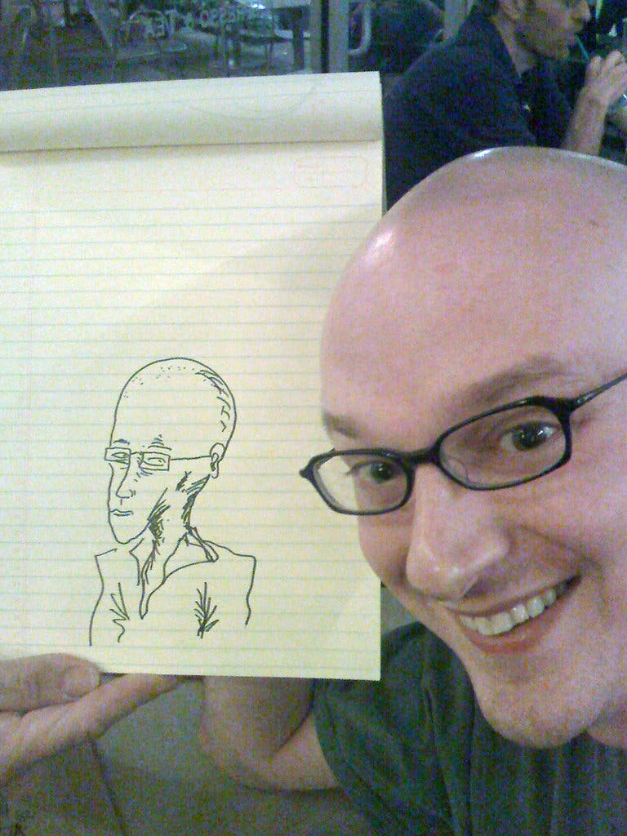
THE BLOGGER Mac Tonnies died at 34 in 2009; his friends rushed in to save his online identity.Credit...Bryan Ring
This point of view has been most convincingly articulated by Dave Winer, the software developer whose Scripting News site is regarded as one of the first examples of what would come to be called blogs. He has been writing about the issue of online content preservation — he calls it “future-safing” — for several years. His views are a surprise to anybody who assumes that expression preserved in bits is somehow more durable than expression preserved in atoms; in fact he has drawn the opposite conclusion, repeatedly pointing out that digital technologies can be surprisingly unstable or can change rapidly in ways that leave a trail of obsolete material in their wake or both. He has written about his own efforts to preserve the original specs and code for some of his most significant technological creations on a suitably reliable server that future historians and others will be able to access. In thinking about how to do the same for his (and others’) online writing, he sounds pessimistic.
At one point he suggested a big company like Amazon or Google might be a suitable repository — maybe charging a flat fee to host content in perpetuity. But lately he has leaned more toward solutions involving institutions like universities or maybe the government. “What’s needed,” he wrote in early 2010, “is an endowment, a foundation with a long-term charter, that can take over the administration of a Web presence as a trust — before the author dies.”
In general, the companies that have created the most popular places and tools for online expression don’t exactly encourage users to stop and think about these subjects. Specific policies vary — details, buried in terms of service agreements, often involve a fair bit of effort, like providing a death certificate — and newer social-media services often have no particular policy at all. (Twitter established its guidelines only in August 2010.) The most prominent place this issue has come up, not surprisingly, is Facebook. For some time now, it has offered an option to request that a profile be switched to “memorial” mode when an individual dies. A post on the company blog explained that the issue first arose internally back in 2005, when one of its employees — there were only 40 at the time — died in a bike accident. (“When someone leaves us, they don’t leave our memories or our social network,” the post said.) Someone must put in a request for a profile to be memorialized, which deactivates certain features and resets various privacy controls, converting its function to a place where friends can leave remembrances. The process doesn’t give much direct control to any heir or executor or similar figure, and as some have complained, it can mean wiping out meaningful material and replacing it with “a thousand ‘sorry this happened’ ” messages, as one user put it.
To Winer, however, the issue goes beyond how a person is remembered by those he or she knew. And he’s right that Web sites come and go — often vanishing in months, depending on the whims and intentions and attention span of their creators. One estimate from the late 1990s suggested that almost half the sites created disappear within one year. The Library of Congress has a program that saves slices of the Web and announced last year that it would archive all tweets. But in general its mission is less a comprehensive record than a representative one, built around themes and events, like Sept. 11. Efforts like Internet Archive’s WaybackMachine are, while impressive, not intended to be complete. Richard Oram, associate director of the Harry Ransom Center at the University of Texas at Austin, recently discussed on NPR the problems of tending archival material stored on old floppy discs. Similarly, saving census data that was once stored on Univac computers was a costly effort, and images recorded by early space missions and stored in now-obsolete formats have simply been lost.
“This is a huge gap in the Web we’re building today,” Winer has written. “Eventually it’s going to catch up with us when we lose a huge amount of stuff we thought we couldn’t lose.”
Cameron Hunt is one of the few people I encountered who is actively trying to preserve his digital identity. A 38-year-old Tampa resident who works in the military-contracting industry, Hunt attended Digital Death Day last year. Many of those who attended had some professional interest in the subject — academics, consultants, entrepreneurs. Hunt’s interest is more personal. He wants to leave a definitive, and stable, digital legacy behind — “a master repository of me,” as he puts it.
His motivations aren’t obvious: he is in good health; he’s divorced and has no children; and unlike Tonnies he is not engaged in traditional acts of creative expression, like writing books. Raised a Mormon, he never really connected to that church’s penchant for genealogy, which always struck him as a bunch of dry lists of names and dates. Then, a couple of years ago, his grandmother died, and he was given a copy of various family stories she had written. “Reading them as an adult, I was able to read between the lines,” he says, “to understand things in a rich way, and see how the stories and the experiences had influenced down through multiple generations.” Something else happened at the same time: the family realized that a big batch of slides in his grandmother’s possession had faded beyond recognition. Hunt was stunned. “Memories that were precious to me — not just living them, but after that going back and revisiting them — and now it’s gone,” he recalls. “I thought: I really need to do something.”
Hunt uses Twitter and Facebook; in fact, he has no privacy restrictions on his Facebook account, which lists his address and cellphone number. “I do that as part of my persona,” he told me when I suggested that it was a bad idea. “My friends know — if there’s an image that maybe I’ve cultivated, it’s ‘Cam’s crazy, he won’t be afraid to do it.’ Therefore opportunities come to me or people confide in me.”
In any case, while he’s also a user of Flickr, LinkedIn, Foursquare and various other online services, the core of his digital legacy is a collection of e-mail dating back to 1994. He has come to realize that achieving his goal is going to take serious effort. “I want to fund a bank account,” he says, “so that when I die, a curator can be paid to digitize anything that may not have been digitized, manage the collection, maybe do some research, help people find stuff if they’re looking for it.
“You know,” he adds with a chuckle, “all these ego-driven things of not being a famous man yet treating my digital afterlife as if I were famous.”
Admittedly, Hunt’s thinking sounds over the top. But part of the reason it seems so audacious is that there is so much to preserve, compared with, say, the physical material his grandmother left behind. A side effect of digital life is that the border between the real-time self-expressive object and the durable memory object has become porous.
Consider Gordon Bell, a famous computer engineer whose innovations date back to the 1960s. More recently he undertook a project under the auspices of Microsoft Research called MyLifeBits, which included not only the totality of his e-mail correspondence but also digital records of Web pages visited, scanned versions of paper notes, recordings of routine conversations and tens of thousands of snapshots taken every 30 seconds by a digital camera that dangles from his neck. Bell suggests that this in fact is ultimately what digital technology is for: “to capture one’s entire life.” As he once told ComputerWorld magazine, the point is not to share it all in real time but to give the individual a tool to “leave a personal legacy — a record of your life.”
Viktor Mayer-Schönberger, in his book “Delete: The Virtue of Forgetting in the Digital Age,” notes Bell as an extreme example of a general cultural drift. It is only relatively recently, he argues, that our tools for recording what we see, experience and think have become so easy to use, inexpensive and effective that it is easier to let information accumulate in our “digital external memories” than it is to bother deleting it. “Forgetting has become costly and difficult, while remembering is inexpensive and easy,” he writes. This is so even though a great deal of our digital expression is simple communication about the present, “intentionally ephemeral.” But because it’s more trouble to delete old blog posts, digital pictures and tweets than it is to make new ones, “society’s ability to forget has become suspended, replaced by perfect memory.”
Mayer-Schönberger is only glancingly concerned with the notion of legacy; he is mostly making a point about privacy and personal information, not about what happens after life ends. So in the long run, his contention that the digital memory is “perfect” is doubtful. And as he notes, even in real time, digital memory can be flawed and misleading: it often merely seems perfect but can be incomplete or even altered.
Stacey Pitsillides, now finishing a graduate degree in design at Goldsmiths, University of London, has been researching digital afterlife issues for a few years now, drawn specifically to the question of what the piles of identity that we’re building up online will ultimately amount to. “We just see it as this infinity,” she says, but it isn’t. “There are certain costs, financial costs, physical and social costs, to keeping this amount of data. One of the social costs is that we kind of lose the ability to begin to choose and arrange what we want to say about ourselves, and instead get lost in this wash of information.
“If every object you’ve ever owned was a memory object,” she continues, “and we gave that to a family member and said, ‘You have to remember this person by all of these objects,’ then what position would we be in, and how would we ever remember everyone?”


‘‘Flickr Birthdays, From 10,852,768 Birthday Pictures on Flickr, 12/22/10’’Credit...Photo Illustration by Penelope Umbrico for The New York Times
It is possible that technology will answer this question with new ways for organizing, sifting and coping with masses of preserved personal data. Richard Banks, an interaction designer for Microsoft Research in Cambridge, England, has made some “technology heirloom” prototypes that collect, say, tweets or Flickr pictures in new physical devices that would automatically organize them (chronologically or thematically) for heirs or others. And a few nascent businesses have lately floated services that aspire to something closer to Cameron Hunt’s “master repository of me” or Gordon Bell’s vision of total memory forever. Something called Lifenaut.com has a product called a MindFile, “a database of personal reflections captured in video, image, audio and documents about yourself that can be saved, searched, downloaded and shared with friends.” This information is meant to be filtered through an “interactive avatar,” modeled on you, “that becomes more intelligent as you add more information.” The site welcomes you with a sweeping, ominous tone; the company’s tag line is “Eternalize.” VirtualEternity.com, from a company called Intellitar, also claims to convert the personal data you provide into an avatar — sort of like one of those chatbots that some online companies use for automated but more humanish customer service. “We want to give users the gift of immortality,” an Intellitar founder has said.
That, to put it mildly, is a hard claim to take seriously. For now, the less pie-in-the-sky issue is whether most people scattering digital objects across the Web have strong feelings about their persistence, or whether, as Mayer-Schönberger suggests, it simply isn’t worth the time to dispose of them. To Hunt, his own project is perfectly consistent with any effort to preserve analog mementos of life, just as his family (and many others) have for many years. “I’m just part of another generation,” he says. “I really don’t think it’s different in instinct or desire from what other people have done — except that so much of that information is quasi-public already.” He has a point there: even if we aren’t obsessing about the persistence of online expression and memory materials, we sure are cranking it out. What’s really surprising is how few Cameron Hunts there are, actively working out which of the digital self-traces they want to preserve, and how to go about it. All he is really trying to do is have some say in how he’s remembered.
My favorite digital-mortality business, DeathSwitch.com, gives the idea of speaking from beyond the grave a Web-era update. DeathSwitch was founded in 2006 by the neuroscientist and writer David Eagleman to coincide with a short story he wrote for Nature, titled “A Brief History of Death Switches.” The story imagines an automated service that allowed its users to send messages after they die. People use it to reveal secret bank accounts to heirs, confess to sins or settle scores from beyond the grave. Over time, uses for this fictional death switch become so elaborate that it is hard to tell that the sender of the message is deceased. That last part hasn’t happened yet, but otherwise the service offered by DeathSwitch.com, in real life, is basically the same as the fictional one: some final words from you, to whomever, after you’ve gone.
DeathSwitch.com has enough subscribers to cover costs, according to Eagleman. It keeps tabs on users by sending a periodic e-mail to make sure they are still alive. I suggested to Eagleman that I would find this regular reminder of my own mortality pretty unnerving, and he seemed perplexed. “If you allow the fact that you are going to pass away,” he replied, “and there are smart things you can do before you pass away to keep everybody in your family happy and well, then it’s as useful as a will, or a do-not-resuscitate.”
Eagleman is an interesting character. He is an assistant professor of neuroscience and psychiatry at Baylor College of Medicine, in Houston, and “Death Switch” is among the short stories collected in a slim, pleasing book he wrote in his spare time, “Sum: Forty Tales From the Afterlives.” As the title suggests, each story imagines some fictional variation on what might come after this life. It’s often quite funny and, as Eagleman points out, can be read as fundamentally hopeful in its willingness to wonder openly and imaginatively about life’s end.
His speculative afterlives end up offering provocative takes on what mortality and legacy really mean. One story posits that there are three deaths, the last coming when your name is spoken for the final time. In another, there is a hell in which you see yourself as others saw you; and in yet another, we sit in the afterlife looking back at life for evidence of our influence, as long as it lingers. “Death Switch,” the story, suggests that there is no afterlife as we think of it but that “a version of us” lives on in the endlessly sophisticated last notes we each send out, creating a strange network of “transactions with no one to read them.” The afterlife isn’t some other place or state of being. “Instead an afterlife occurs for that which exists between us.”
MAC TONNIES’S MANY eclectic intellectual pursuits included at least a passing interest in the notion of cyberimmortality. The idea of the self escaping bodily death by transforming into an age-proof, sickness-proof essence that can be uploaded into a computer or network dates back at least to Vernor Vinge’s 1981 novella “True Names.” A year after that, William Gibson gave us the word “cyberspace” to describe a new place where humans might exist, potentially forever, outside the physical world. By the 1990s, as the Internet became a familiar presence in many people’s lives, some began to suggest that this was no mere science-fiction scenario; it was the future. Vinge was among those (along with, notably, Ray Kurzweil) to discuss the transformation of humans by technology, coming in a matter of decades, referred to as “the singularity.” The Carnegie Mellon robotics expert Hans Moravec, the artificial-intelligence pioneer Marvin Minsky, the computer scientist Rudy Rucker and others articulated visions of a future in which technology might truly free us from “the bloody mess of organic matter,” to use a phrase of Minsky’s. In her 1999 book, “The Pearly Gates of Cyberspace,” Margaret Wertheim contextualized such speculations as attempts to, in effect, “construct a technological substitute for the Christian space of heaven.”
Wertheim pointed out that cyberspace had become a new kind of place, where alternate (or at least carefully curated or burnished) identities could be forged, new forms of collectivity and connection explored, all outside the familiar boundaries of the physical world, like the body and geography. It’s not such a long journey to follow those assertions to the “view that man is defined not by the atoms of his body but by an information code,” as Wertheim wrote. “This is the belief that our essence lies not in our matter but in a pattern of data.” She called this idea the “cybersoul,” a “posited immortal self, this thing that can supposedly live on in the digital domain after our bodies die.”
And that, essentially, is what is implied by Gordon Bell’s assertion that his MyLifeBits project is a way to “leave a personal legacy — a record of your life.” Or to put it more prosaically, it’s the same thing Trendwatching.com meant by calling your digital traces on social networks the “nucleus of one’s personal brand.” It’s what the uncanny avatars of Lifenaut and Virtual Eternity hope one day to encapsulate. It’s at the heart of “singularity” theory.
Wertheim, it should be noted, saw the cybersoul notion as both flawed and troubling, and I would agree. Life’s essence reduced to captured data is an uninspiring, and unconvincing, resolution to the centuries-old question of where, in mind and in body, the self resides. At least other imagined versions of immortality (from the Christian heaven to the Hindu wheel of life) suggested a reconciliation, or at least a connection, with the manner in which a physical life is lived; the cybersoul’s theoretically eternal and perfect persistence ignores this concept. Most of all, though, fantasizing about living forever — in heaven or in a preserved pattern of data — strikes me as just another way of avoiding any honest confrontation with the fact of death.
Avoiding that confrontation isn’t merely a stumbling block for those digital-afterlife start-ups. I was struck by how many of the people I spoke to who professed a keen interest in the issue of preserving a digital legacy had in fact done absolutely nothing about it for themselves. “Hmm, that’s a good question,” one of the organizers of that Digital Death Day event, a Web-identity expert, replied when I asked her why she had not taken steps to plan for the future of her digital creations. “I’m probably afraid of resolving the issue,” another online-expression enthusiast offered (before joking that all he really wanted to do is “save my work better than my enemies save theirs”). Actually, I completely empathize. I’m not anxious to resolve the issue either, at least not by making any prolonged and thoughtful effort centered on the extended contemplation of my demise.
For me, at least, pondering the digital afterlife made me rethink digital life. We’re encouraged to record and express everything, all the time. In real time, we can record and distribute the most important moments of our existence, and some of the least. For the generations growing up in the Web era, this mode of being is more or less taken for granted. But the tools we use privilege the moment, not the long term; they also tend to make everything feel roughly equal in importance and offer us little incentive to comb back through our digital scribblings and sort out what might have lasting meaning from what probably doesn’t. The results are pretty much the opposite of a scrapbook carefully edited to serve as a memory object but could end up serving that function by default.
If “digital litter” is all around us, then thinking about how to clean it up in real time — or producing less of it in the first place — might be more productive. Rita King, the online-identity expert who was a friend of Mac Tonnies’s, is clearly pleased to have access to his online effects and generally optimistic about new forms of remembering that digital technologies might enable. At the same time, though, she expressed some caution about the mindless expression of everything, the default veneration of “sharing” over “curating.” While she’s clearly an online-life enthusiast, she’s also careful about what she discloses in that new form of space. “If people thought about dying more often,” she observed, “they’d think about living differently.”
I found myself wondering, oddly enough, about what Mac Tonnies’s take might be. The last of his friends to whom I spoke was Paul Kimball, a filmmaker who lives in Nova Scotia. He met Tonnies online about a decade ago; they corresponded for six years before meeting in person, when Kimball came to Kansas City to interview Tonnies for a documentary. They ended up becoming close, even collaborating on a play (swapping drafts via e-mail) that was staged at the Boulder International Fringe Festival.
Among their shared interests, it turns out, was the relationship among technology, consciousness and mortality. Their play, based on a science-fiction story Tonnies had written in college, involves two women who turn out not to be, strictly speaking, creatures of organic matter: one is an artificial-intelligence program, the other a human consciousness uploaded into a form that could survive a centuries-long space journey. The very title of Tonnies’s Posthuman Blues blog, Kimball points out, hints at ambivalence about these subjects. But that was the place, he says, where his generally private friend “revealed himself,” post by post. The fact that the blog persists, in public, is what makes it distinct from, say, a journal Kimball owns that belonged to his grandfather and that has been read by perhaps 20 people.
The day before we spoke, Kimball continued, he had linked to an old Posthuman Blues post on his Facebook page, seeking reactions from his own online circle. “So I’m still having this conversation” with his friend Tonnies, he told me, “even though he’s been dead for more than a year.” Eventually, Kimball added, such situations may be routine. “We’re entering a world where we can all leave as much of a legacy as George Bush or Bill Clinton. Maybe that’s the ultimate democratization,” he said. “It gives all of us a chance at immortality.”
After talking to Kimball, I ended up watching a couple of interview clips of Tonnies on YouTube. In one, he discussed “transhumanism,” the techno-scientific quest to transcend the traditional limits of the human animal, death included, whether through merging with machines or fiddling with our genes. Skeptics or opponents of transhumanism are missing the point that it’s well underway, he argued: medicine is transhuman, in that it thwarts mortality. While I didn’t find this wholly convincing, I will concede that it was interesting to find myself in a position to listen to his arguments at all. It made me wish I could offer Tonnies my counterpoints — but of course I can’t. So I’ll give him the last word. “I like to think of death as a glorified terminal illness,” Mac Tonnies said, and will continue to say, for as long as this particular collection of bits remains available for someone to watch and listen to. “If we can escape the boundaries of death, maybe we’ll be O.K.”

